Iranian Journal of Electrical and Electronic Engineering No. (YEAR) pp-pp



**Preparation of the Accepted Papers for Iranian Journal of Electrical and Electronic Engineering (IJEEE)**

First A. Author*, Second B. Author**(C.A.) and Third C. Author**

**Abstract:** The abstract is a brief (150-200 words) synopsis of your full paper. Its use is to provide a quick outline of your presentation, giving the reader an overview of the research. This is an important aspect of your paper, as it is this description that may attract the reader to continue and finish reading your full paper. In particular, the main contributions of the paper should be explicitly mentioned in the abstract. No citations or cross-references should be used there.

**Keywords:** Keywords should be so chosen that they best describe the contents of the paper. About four keywords or phrases in alphabetical order, separated by commas, such as: Digital Redesign, Optimal Control, Robotics.

[1]

# Introduction

T

HE Iranian Journal of Electrical and Electronic Engineering (IJEEE), publishes original research papers pertaining to the physical/mathematical analysis and synthesis of engineering elements and systems. These instructions give you the basic guidelines for final preparation of papers accepted for publication in the IJEEE.

# How to Format the Pages

## Fonts

The best results will be obtained if your computer word-processor has several font sizes. The main font used throughout the document is Times New Roman. Try to follow the font sizes specified in Table 1, as best as you can.

## Format

The length of a paper is limited to 8 pages of two- column and single-spaced. In formatting your A4-size paper, the top margin should be set to 30 mm, bottom margin to 30 mm, left margin to 20 mm and right margin to 20 mm. The column width is 80 mm with 10 mm space between the two columns. Columns should be left- and right justified. The heights of the last two columns of the paper should be equal. Don't forget to check the spelling.

**Table 1** Font sizes used in the paper.

|  |  |  |  |
| --- | --- | --- | --- |
| Font Size | Bold | Italic | Text |
| 10 | × | × | Main text, references, authors’ affiliations |
| 10 | √ | × | Headings and sub-headings e.g., Abstract |
| 11 | × | × | Authors' names |
| 18 | √ | × | Paper title |
| 9 | × | × | Table numbers, table captions, figure captions |
| 8 | × | × | Footnotes, sub- and superscripts |

# Illustrations

Position figures and tables at the tops and bottoms of columns, if possible. Large figures, tables and equations may span both columns. Figure captions should be below the figures; table captions should be above the tables. Try to place the figures and tables after their first citation in the text. If your figure has two parts, include the labels “(a)” and “(b)” as part of the artwork. Please verify that the figures and tables you mention in the text actually exist. Please do not include captions as part of the figures. Do not put captions in “text boxes” linked to the figures. Do not put borders around the outside of your figures. Use the abbreviation (e.g., "Fig. 1") even at the beginning of a sentence. Do not abbreviate “Table.”

All half-tone illustrations (pictures/photographs) should be clear black and white prints. Do not use photocopies.

Figure axis labels are often a source of confusion. Use words rather than symbols. As an example, write the quantity “Magnetization,” or “Magnetization M,” not just “M.” Put units in parentheses. Do not label axes only with units. As in Fig. 1, for example, write “Magnetization (A/m)” or “Magnetization (A.m-1),” not just “A/m.” Do not label axes with a ratio of quantities and units. For example, write “Temperature (K),” not “Temperature/K.”

Multipliers can be especially confusing. Write “Magnetization (kA/m)” or “Magnetization (103 A/m).” Do not write “Magnetization (A/m)×1000” because the reader would not know whether the top axis label in Fig. 1 meant 16000 A/m or 0.016 A/m.

# Citations and References

List and number all references at the end of the paper. Multiple references [1], [2] are each numbered with separate brackets. When referring to them in the text, type the corresponding reference number in square brackets as shown at the end of this sentence: [1] and [2]. Also use the referencing style for papers and books as shown by [1] and [2], respectively. Number the citations consecutively. The sentence punctuation follows the brackets. Do not use "Ref. [3]" or "reference

[3]" except at the beginning of a sentence. Capitalize only the first word in paper title, except for proper nouns and element symbols.

Please note that the references at the end of this document are in the preferred referencing style. Give all authors’ names; do not use “et al.”. Use a space after authors’ initials. Papers that have not been published should be cited as “unpublished”. Papers that have been accepted for publication, but not yet specified for an issue should be cited as “to be published”. Papers that have been submitted for publication should be cited as “submitted for publication”.

# Abbreviations and Acronyms

Define abbreviations and acronyms the first time they are used in the text, even after they have already been defined in the abstract. Abbreviations such as IEEE, SI, ac, and dc do not have to be defined. Abbreviations that incorporate periods should not have spaces: write “C.N.R.S.,” not “C. N. R. S.” Do not use abbreviations in the title unless they are unavoidable.

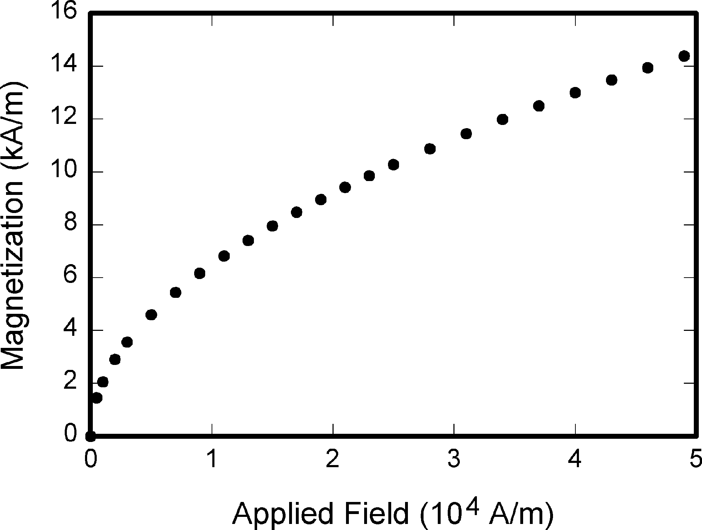

**Fig. 1** Magnetization as a function of applied field. Note that “Fig.” is abbreviated.

# Equations

If you are using Word, use either the Microsoft Equation Editor or the MathType for equations in your paper.

Number equations consecutively with equation numbers in parentheses flush with the right margin, as in Eq. (1).

The detailed sizes of equations are Full: 10pt, Subcript/Superscript: 5pt, Sub- Subcript/Superscript: 4pt, Symbol: 13pt and Sub-Symbol: 10pt and equations are non-italic and non-bold.



Be sure that the symbols in your equation have been defined before the equation appears or immediately following. When you refer to equations in the text, refer to "Eq. (1)" or "Equation (1)" except at the beginning of a sentence: "Equation (1) is used”

# Units

Use either SI (MKS) or CGS as primary units. (SI units are strongly encouraged.) Avoid combining SI and CGS units, such as current in amperes and magnetic field in oersteds. This often leads to confusion because equations do not balance dimensionally. If you must use mixed units, clearly state the units for each quantity in an equation.

The SI unit for magnetic field strength H is A/m. However, if you wish to use units of T, either refer to magnetic flux density B or magnetic field strength symbolized as µ0H. Use the center dot to separate compound units, e.g., “A.m2”.

# Other Recommendations

Use one space after periods and colons. Avoid dangling participles, such as, “Using (1), the potential was calculated.” [It is not clear who or what used (1).] Write instead, “The potential was calculated by using

(1),” or “Using (1), we calculated the potential.”

Use a zero before decimal points: “0.25,” not “.25.” Use “cm3,” not “cc.” Indicate sample dimensions as “0.1 cm × 0.2 cm,” not “0.1 × 0.2 cm2.” The abbreviation for “seconds” is “sec.” not “s”. Do not mix complete spellings and abbreviations of units: use “Wb/m2” or “webers per square meter,” not “webers/m2.” When expressing a range of values, write “7 to 9” or “7-9,” not “7~9.”

Avoid contractions; for example, write “do not” instead of “don’t.” The serial comma is preferred: “A, B, and C” instead of “A, B and C.”

If you wish, you may write in the first person singular or plural and use the active voice (“I observed that ...” or “We observed that ...” instead of “It was observed that ...”). Remember to check spelling. If your native language is not English, please get a native English- speaking colleague to carefully proofread your paper.

# Some Common Mistakes

The word “data” is plural, not singular. The subscript for the permeability of vacuum µ0 is zero, not a lowercase letter “o.” The term for residual magnetization is “remanence”; the adjective is “remanent”; do not write “remnance” or “remnant.” Use the word “micrometer” instead of “micron.” A graph within a graph is an “inset,” not an “insert.” The word “alternatively” is preferred to the word “alternately” (unless you really mean something that alternates). Use the word “whereas” instead of “while” (unless you are referring to simultaneous events). Do not use the word “essentially” to mean “approximately” or “effectively.” Do not use the word “issue” as a euphemism for “problem.” When compositions are not specified, separate chemical symbols by en-dashes; for example, “NiMn” indicates the intermetallic compound Ni0.5Mn0.5 whereas “Ni–Mn” indicates an alloy of some composition NixMn1-x.

Be aware of the different meanings of the homophones “affect” (usually a verb) and “effect” (usually a noun), “complement” and “compliment,” “discreet” and “discrete,” “principal” (e.g., “principal investigator”) and “principle” (e.g., “principle of measurement”). Do not confuse “imply” and “infer.”Prefixes such as “non,” “sub,” “micro,” “multi,” and “ultra” are not independent words; they should be joined to the words they modify, usually without a hyphen. There is no period after the “et” in the Latin abbreviation “et al.”. The abbreviation “i.e.,” means “that is,” and the abbreviation “e.g.,” means “for example” (these abbreviations are not italicized).

# Conclusion

Although a conclusion may review the main points of the paper, do not replicate the abstract as the conclusion. A conclusion might elaborate on the importance of the work or suggest applications and extensions.

### Conflict of Interest

All financial, commercial or other relationships that might be perceived by the academic community as representing a potential conflict of interest must be disclosed. If no such relationship exists, authors will be asked to confirm the following statement:

*The authors declare no conflict of interest*.

### Author Contributions

The Author Contributions section is mandatory for all articles, including articles by sole authors. The Author Contributions statement must describe the contributions of individual authors referred to by their initials and, in doing so, all authors agree to be accountable for the content of the work.

### Funding

Details of all funding sources should be provided, including grant numbers if applicable. Please ensure to add all necessary funding information, as after publication this is no longer possible.

### Informed Consent Statement

Any research article describing a study involving humans must contain this statement. Please add “Informed consent was obtained from all subjects involved in the study.” OR “Patient consent was waived due to REASON (please provide a detailed justification).” OR “Not applicable.” for studies not involving humans. You might also choose to exclude this statement if the study did not involve humans.

Written informed consent for publication must be obtained from participating patients who can be identified (including by the patients themselves). Please state “Written informed consent has been obtained from the patient(s) to publish this paper” if applicable.

### Acknowledgment

The authors wish to thank A, B, C. This work was supported in part by a grant from XYZ.

### Appendix

Appendices, if needed, appear before the acknowledgment.

### References

1. Cotter N. E. and Guillerm T. J., “The CMAC and a theorem of Kolmogorov,” *Neural Networks*, Vol. 5, No. 2, pp. 221-228, Feb. 1992.
2. Zhou K., Doyle J. C. and Glover K., *Robust and optimal control*, chapter 3, Englewood cliffs, NJ, USA: Prentice-Hall, 1996.

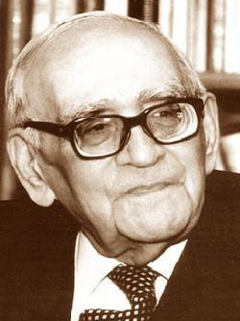**All Authors** may include biographies at the end of papers. It may contain a place and/or date of birth (list place, then date). Next, the author’s educational background is listed. The degrees should be listed with type of degree in what field, which institution, city, state, and country, and year degree was earned. Finally, the author’s work experience, current and previous jobs, publications and

any awards are listed.

If a photograph is provided, the biography will be indented around it. The photograph is placed at the top left of the biography. Personal hobbies will be deleted from the biography.

**Instructions to Authors of Papers for the**

**Iranian Journal of Electrical and Electronic Engineering (IJEEE)**

# Scope

The Iranian Journal of Electrical & Electronic Engineering (IJEEE) is a peer reviewed journal devoted to publish original papers of high technical standard with a suitable balance of practice and theory related to the broad topics in the field of electrical engineering. All topics are treated with similar emphasis, such as:

* + - Biomedical Engineering,
    - Communication Engineering,
    - Computer Engineering,
    - Control Engineering,
    - Electronic Engineering,
    - Power Engineering.

# Language

Papers should be written in English.

# Typescript

The prospective authors should prepare two files for each manuscript; one with full author's information (name, Email address, postal address, affiliation and biography) and the other without any author's information. Manuscripts should be typed one-column, double-spaced; 12 point Times New Roman font and 2.5-cm margins in standard A4 paper (21 by 29.7 cm2). An abstract of 150-200 words should be included. Authors should supply about four key words or phrases that characterize their manuscript. The paper should be reasonably subdivided into sections and, if necessary, subsections. Manuscripts should not exceed 8 printed pages [approximately 16 double spaced A4 pages plus almost 14 illustrations]. The required format for the final version of the accepted papers may be obtained at ijeee.iust.ac.ir.

# Illustrations

Illustrations enclosed when a paper is first submitted need not be suitable for reproduction, but they must be clear for the purpose of review. As much text as possible should be removed from illustrations, and any background line in graphs not be obscured.

# References

Other publications referred to in the text should be indicated by a number. Details of the references should be given in a list at the end of the paper in order of citation. Each reference should include:

1. Names of all the authors (i.e. not 'et al.'),
2. Title of the paper,
3. Full title of the journal,
4. Year of publication and volume number,
5. First and last page numbers.

For a book, the author, book title, publisher and year of the publication should be stated.

# Submission

Authors are invited to submit the files of their manuscript via IJEEE on-line submission at ijeee.iust.ac.ir. A signed copyright transfer agreement and originality statement, downloaded at ijeee.iust.ac.ir, are needed. All submission and further tracking of submitted papers should be done through ijeee.iust.ac.ir.

1. Iranian Journal of Electrical & Electronic Engineering, YYYY.

   Paper first received DD MONTH YYYY and accepted DD MONTH YYYY.

   * The author is with the Department of XXX, YYY University, Address.

   E-mail: [xxx@xxx.xxx.xxx.](mailto:xxx@xxx.xxx.xxx)

   ** The authors are with the Department of XXX, YYY University, Address.

   E-mails: [yyy@yyy.yyy.yyy,](mailto:yyy@yyy.yyy.yyy) [zzz@zzz.zzz.zzz.](mailto:zzz@zzz.zzz.zzz)

   Corresponding Author: Second B. Author.